|  |  |  |  |
| --- | --- | --- | --- |
| Name:  Class: | ____________________________________  ________________ | | Date:_________ |
|  | **Year 11 Essential Mathematics**  / 44  6 %  **Major Test 3 2018**  **Topic – Units of Energy, Formulas and Graphs** | | |
| **Total Time:** | 50 minutes |  | |
| **Weighting:** | 6% |
| **Equipment:** | To be provided by the student: Pen, pencil, ruler,1 double sided A4 page of notes, scientific calculator | | |

**Full working out must be shown to get full marks. Attempt all questions.**

|  |
| --- |
| **Question 1  *2* marks** |

|  |  |  |
| --- | --- | --- |
|  | |  | | --- | | If there were a total of 205 young adults surveyed, approximately how many preferred Rock and Roll?  Rock and Roll | |
|  | http://www.schools.nsw.edu.au/learning/7-12assessments/naplan/teachstrategies/yr2012/images/data_table_04_09.jpg    The amount in the bank for Week 4 is how much greater that the amount for Week 2. |

|  |
| --- |
| **Question 2  *6* marks (3, 1, 1, 1)** |

56 children were asked which of the following hobbies they prefer. Their results are recorded in the table below.

1. Complete the missing values

|  |  |  |  |  |
| --- | --- | --- | --- | --- |
|  | Computer games | Watch Films | Read | Total |
| Girls | 5 |  |  | 22 |
| Boys |  | 11 |  |  |
| Total | 24 |  | 10 | 56 |

1. How many boys prefer computer games?
2. What percentage of children watched films?
3. What percentage of girls read books?

|  |
| --- |
| **Question 3**  *7* **marks** |

The line graph shows the temperatures over the year in Jamaica

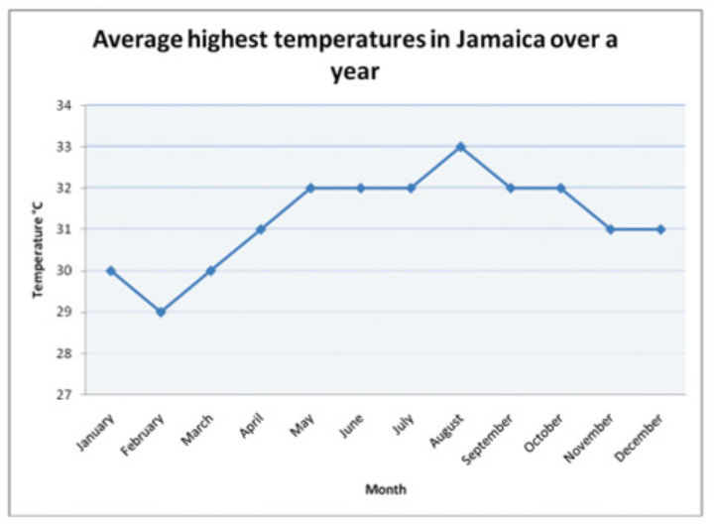

Use the graph to answer the following questions:

1. Which month had the highest temperature
2. Which month had the lowest temperature
3. What is the difference in temperature between February and May?
4. How many months have a higher temperature than 30 ֯ C
5. Would you expect the temperature range in Australia to be similar or different ? Explain your answer

|  |
| --- |
| **Question 4 *8*****marks** |

From the list of data displays below, choose the most appropriate way to display the data described in each part below and explain the reasons for you choice.

* *Column graph*
* *Line graph*
* *Clustered column graph*
* Pie graph

1. The heights (measured in cm) of 20 boys and 20 girls to compare them.

*Appropriate data display:*

*Reason:*

1. Home loan rates every November for the last 10 years

*Appropriate data display:*

*Reason:*

1. The foot length, measured in cm, of the members of your class.

*Appropriate data display:*

*Reason:*

1. The percentage of students in each year at our school.

*Appropriate data display:*

*Reason:*

|  |
| --- |
| **Question 5  *12*****marks** |

A survey of 30 students was conducted. The data is shown below. The information was recorded as M for Male, F for Female, and then a number was the shoe size.

11M, 10F, 9F, 9M, 9M, 10F, 11F, 8F,12F, 11M, 6F, 7M, 7F, 10M, 12M, 11F, 12M, 6F, 7M, 8M, 8M, 8F, 7F, 11M, 10M, 12M, 10F, 9F,7F,10M

Construct an appropriate graph

|  |  |  |  |  |  |  |  |  |  |  |  |  |  |  |  |  |  |  |  |
| --- | --- | --- | --- | --- | --- | --- | --- | --- | --- | --- | --- | --- | --- | --- | --- | --- | --- | --- | --- |
|  |  |  |  |  |  |  |  |  |  |  |  |  |  |  |  |  |  |  |  |
|  |  |  |  |  |  |  |  |  |  |  |  |  |  |  |  |  |  |  |  |
|  |  |  |  |  |  |  |  |  |  |  |  |  |  |  |  |  |  |  |  |
|  |  |  |  |  |  |  |  |  |  |  |  |  |  |  |  |  |  |  |  |
|  |  |  |  |  |  |  |  |  |  |  |  |  |  |  |  |  |  |  |  |
|  |  |  |  |  |  |  |  |  |  |  |  |  |  |  |  |  |  |  |  |
|  |  |  |  |  |  |  |  |  |  |  |  |  |  |  |  |  |  |  |  |
|  |  |  |  |  |  |  |  |  |  |  |  |  |  |  |  |  |  |  |  |
|  |  |  |  |  |  |  |  |  |  |  |  |  |  |  |  |  |  |  |  |
|  |  |  |  |  |  |  |  |  |  |  |  |  |  |  |  |  |  |  |  |
|  |  |  |  |  |  |  |  |  |  |  |  |  |  |  |  |  |  |  |  |
|  |  |  |  |  |  |  |  |  |  |  |  |  |  |  |  |  |  |  |  |
|  |  |  |  |  |  |  |  |  |  |  |  |  |  |  |  |  |  |  |  |
|  |  |  |  |  |  |  |  |  |  |  |  |  |  |  |  |  |  |  |  |
|  |  |  |  |  |  |  |  |  |  |  |  |  |  |  |  |  |  |  |  |
|  |  |  |  |  |  |  |  |  |  |  |  |  |  |  |  |  |  |  |  |
|  |  |  |  |  |  |  |  |  |  |  |  |  |  |  |  |  |  |  |  |
|  |  |  |  |  |  |  |  |  |  |  |  |  |  |  |  |  |  |  |  |
|  |  |  |  |  |  |  |  |  |  |  |  |  |  |  |  |  |  |  |  |
|  |  |  |  |  |  |  |  |  |  |  |  |  |  |  |  |  |  |  |  |

Using your graph, answer the following information:

1. What was the most common shoe size for both genders?
2. Which gender had more samples?
3. What percentage of all recorded shoe sizes are the size 11 results.
4. What proportion of all boys had a shoe size below a size 10? *Leave your answer as a %*

|  |
| --- |
| **Question 6** ***5* marks** |

1. Make 2 comments about how the graph below showing the number of people who own different types of pets, is misleading.

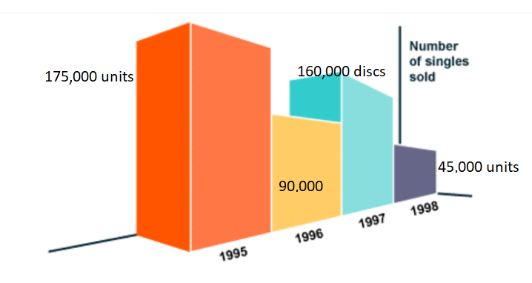

1. Redraw this column graph, making the necessary improvements to make this graph accurate

|  |  |  |  |  |  |  |  |  |  |  |  |  |  |  |  |  |  |  |  |
| --- | --- | --- | --- | --- | --- | --- | --- | --- | --- | --- | --- | --- | --- | --- | --- | --- | --- | --- | --- |
|  |  |  |  |  |  |  |  |  |  |  |  |  |  |  |  |  |  |  |  |
|  |  |  |  |  |  |  |  |  |  |  |  |  |  |  |  |  |  |  |  |
|  |  |  |  |  |  |  |  |  |  |  |  |  |  |  |  |  |  |  |  |
|  |  |  |  |  |  |  |  |  |  |  |  |  |  |  |  |  |  |  |  |
|  |  |  |  |  |  |  |  |  |  |  |  |  |  |  |  |  |  |  |  |
|  |  |  |  |  |  |  |  |  |  |  |  |  |  |  |  |  |  |  |  |
|  |  |  |  |  |  |  |  |  |  |  |  |  |  |  |  |  |  |  |  |
|  |  |  |  |  |  |  |  |  |  |  |  |  |  |  |  |  |  |  |  |
|  |  |  |  |  |  |  |  |  |  |  |  |  |  |  |  |  |  |  |  |
|  |  |  |  |  |  |  |  |  |  |  |  |  |  |  |  |  |  |  |  |
|  |  |  |  |  |  |  |  |  |  |  |  |  |  |  |  |  |  |  |  |
|  |  |  |  |  |  |  |  |  |  |  |  |  |  |  |  |  |  |  |  |
|  |  |  |  |  |  |  |  |  |  |  |  |  |  |  |  |  |  |  |  |
|  |  |  |  |  |  |  |  |  |  |  |  |  |  |  |  |  |  |  |  |
|  |  |  |  |  |  |  |  |  |  |  |  |  |  |  |  |  |  |  |  |
|  |  |  |  |  |  |  |  |  |  |  |  |  |  |  |  |  |  |  |  |
|  |  |  |  |  |  |  |  |  |  |  |  |  |  |  |  |  |  |  |  |
|  |  |  |  |  |  |  |  |  |  |  |  |  |  |  |  |  |  |  |  |
|  |  |  |  |  |  |  |  |  |  |  |  |  |  |  |  |  |  |  |  |
|  |  |  |  |  |  |  |  |  |  |  |  |  |  |  |  |  |  |  |  |

**Question 7** ***4* marks**

The table below shows a breakdown of Jill’s monthly expenditure.

1. Fill in the missing boxes in the table below.

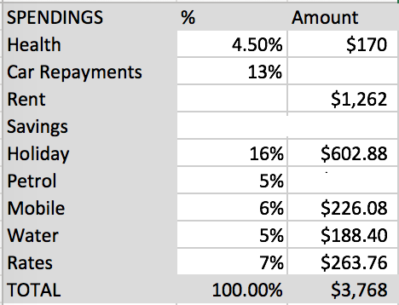

1. Jill makes a pie chart to easily see her spending breakdown. Fill in the missing sectors using the table above.

**-END OF TEST-**